PROJECT REPORT

PREDICTING LIFE EXPECTANCY

Name: Mayank Sharma

E-Mail: [mayanksharma1902@gmail.com](mailto:mayanksharma1902@gmail.com)

Category: Machine Learning

College: SRM Institute of Science And Technology

Webpage Link:

<https://node-red-tqrub.eu-gb.mybluemix.net/ui>

1.) INTRODUCTION

1.1) OVERVIEW

Life expectancy is a statistical measure of the average time a human being is expected to live, Life expectancy depends on various factors: Regional variations, Economic Circumstances, Sex Differences, Mental Illnesses, Physical Illnesses, Education, Year of their birth and other demographic factors. It is very important to predict average life expectancy of a country to analyse further requirements to increase its rate of growth or stabilize the rate of growth in that country. So this is a typical Regression Machine Learning project that leverages historical data to predict insights into the future. The end product will be a webpage where you need to give all the required inputs and then submit it. Afterwards it will predict the life expectancy value based on your regression technique.

Project Requirements: Python, IBM Cloud, IBM Watson

Functional Requirements: IBM cloud

Technical Requirements: ML, WATSON Studio, Python, Node-Red

Software Requirements: Watson Studio, Node-Red

Project Deliverables: Smartinternz

Internship Project Team: Mayank Sharma

Project Duration: 1 Month

1.2) PURPOSE

longevity is based on many factors, not all of which are captured here. This will ask

about your illness such as HIV/AIDS and POLIO, Age, Region, or Country you belong

to, consumes Alcohol or Not, Education, and Income composition. The results are

based on Statistical Regression. This will predict Your Age when you will Die.

2.) LITERATURE SURVEY

2.1) EXISTING PROBLEM

A typical Regression Machine Learning project leverages historical data to predict insights into the future. This problem statement is aimed at predicting Life Expectancy rate of a country given various features. Life expectancy is a statistical measure of the average time a human being is expected to live, Life expectancy depends on various factors: Regional variations, Economic Circumstances, Sex Differences, Mental Illnesses, Physical Illnesses, Education, Year of their birth and other demographic factors. This problem statement provides a way to predict average life expectancy of people living in a country when various factors such as year, GDP, education, alcohol intake of people in the country, expenditure on healthcare system and some specific disease related deaths that happened in the country are given.

2.2) PROPOSED SOLUTION

STEPS:

a) Create IBM cloud services

b) Configure Watson Studio

c) Create Node-Red Flow to connect all services together

d) Deploy and run Node-Red app

2.2.1) Create IBM Cloud Services

• Watson Studio

• Machine Learning

• Node-RED

3.) THEORETICAL ANALYSIS

3.1) BLOCK DIAGRAM

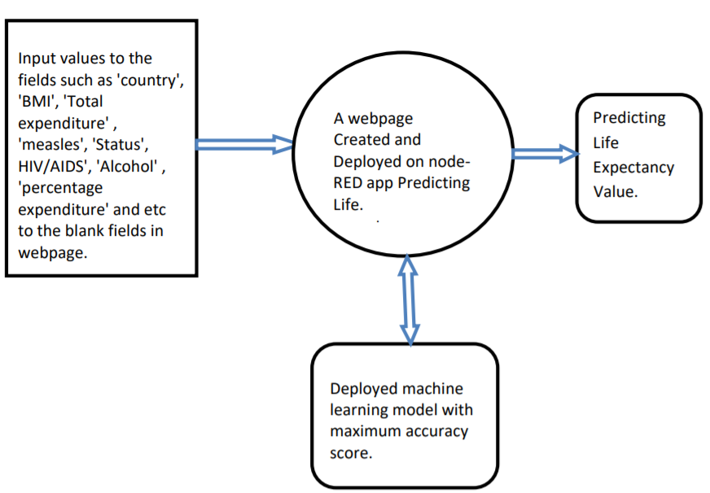

3.2) HARDWARE/SOFTWARE DESIGNING

• PROJECT REQUIREMENTS

➢ Python

➢ IBM Cloud

➢ IBM Watson

• FUNCTIONAL REQUIREMENTS

➢ IBM Cloud

• TECHNICAL REQUIREMENTS

Input values to the fields such as 'country', 'BMI', 'Total expenditure' , 'measles', 'Status', HIV/AIDS', 'Alcohol' , 'percentage expenditure' and etc to the blank fields in webpage. A webpage Created and Deployed on nodeRED app Predicting Life. expectancy . Predicting Life Expectancy Value. Deployed machine learning model with maximum accuracy score.

**4. EXPERIMENTAL INVESTIGATIONS**

Analyzing every feature in our dataset is very important which helps us to build a model which gives more accurate result.

1. **IBM Cloud Resource List**

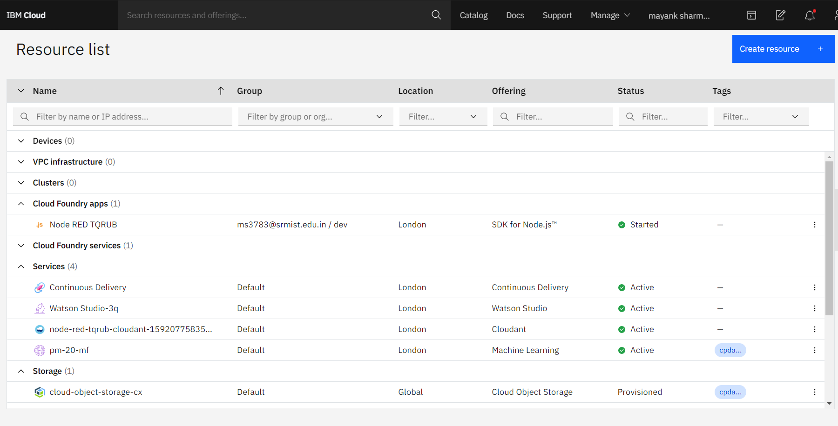

**B) IBM Cloud Project Details**

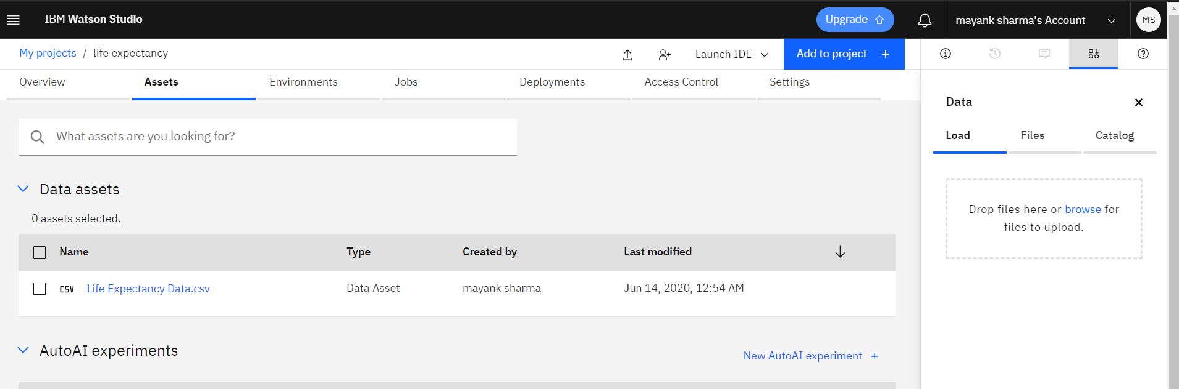

**C) Node-Red Flow**

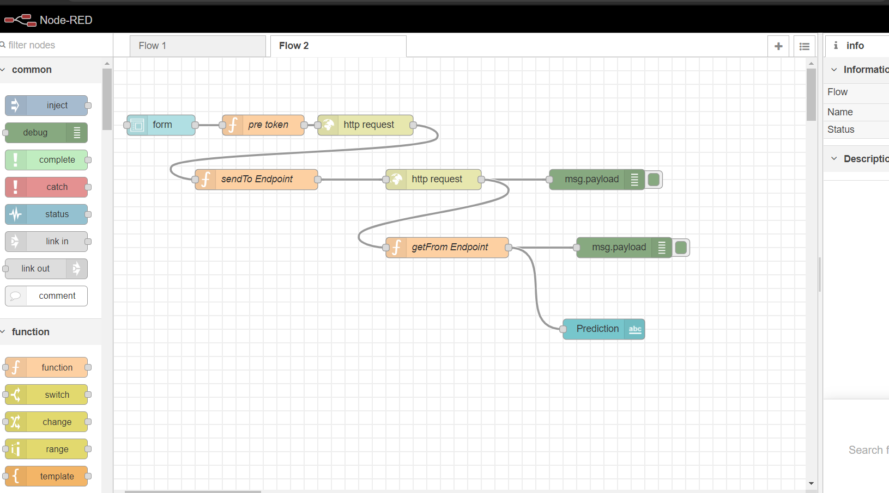

**D) Life Expectancy Prediction UI**

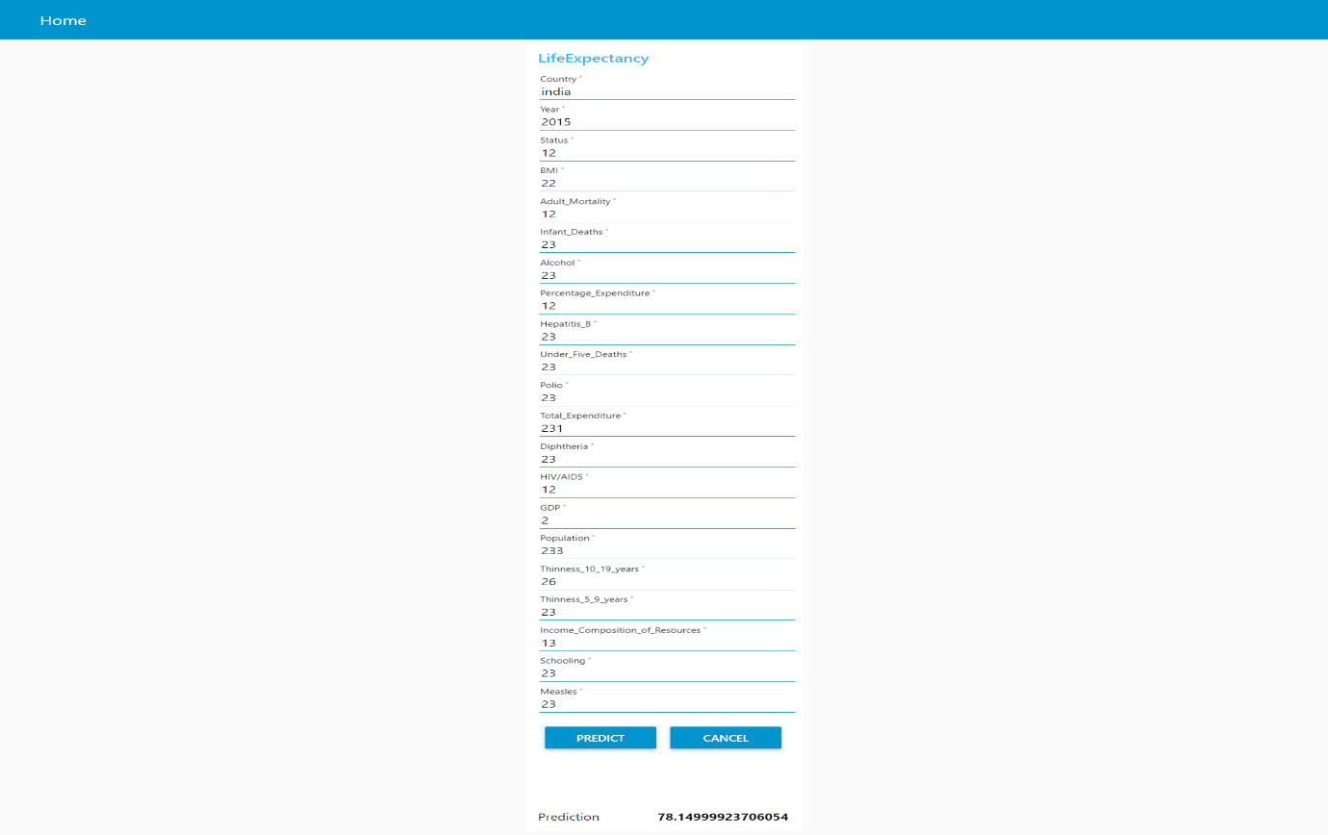

**FLOWCHART**



The above flow chart can be explained in reference to my project in the following way:

1. a) Firstly, the user will provide input for all the required values .

b) The data then entered into watson and the scoring endpoint url matches with the

1. deployed model.
2. c) Then it enters into trained data and predicts the life expectancy value .
3. 6. RESULT
4. The end product or the required result will be a webpage where you need to give all the required inputs and then submit it . Afterwards it will predict the life expectancy value based on your regression technique.
5. 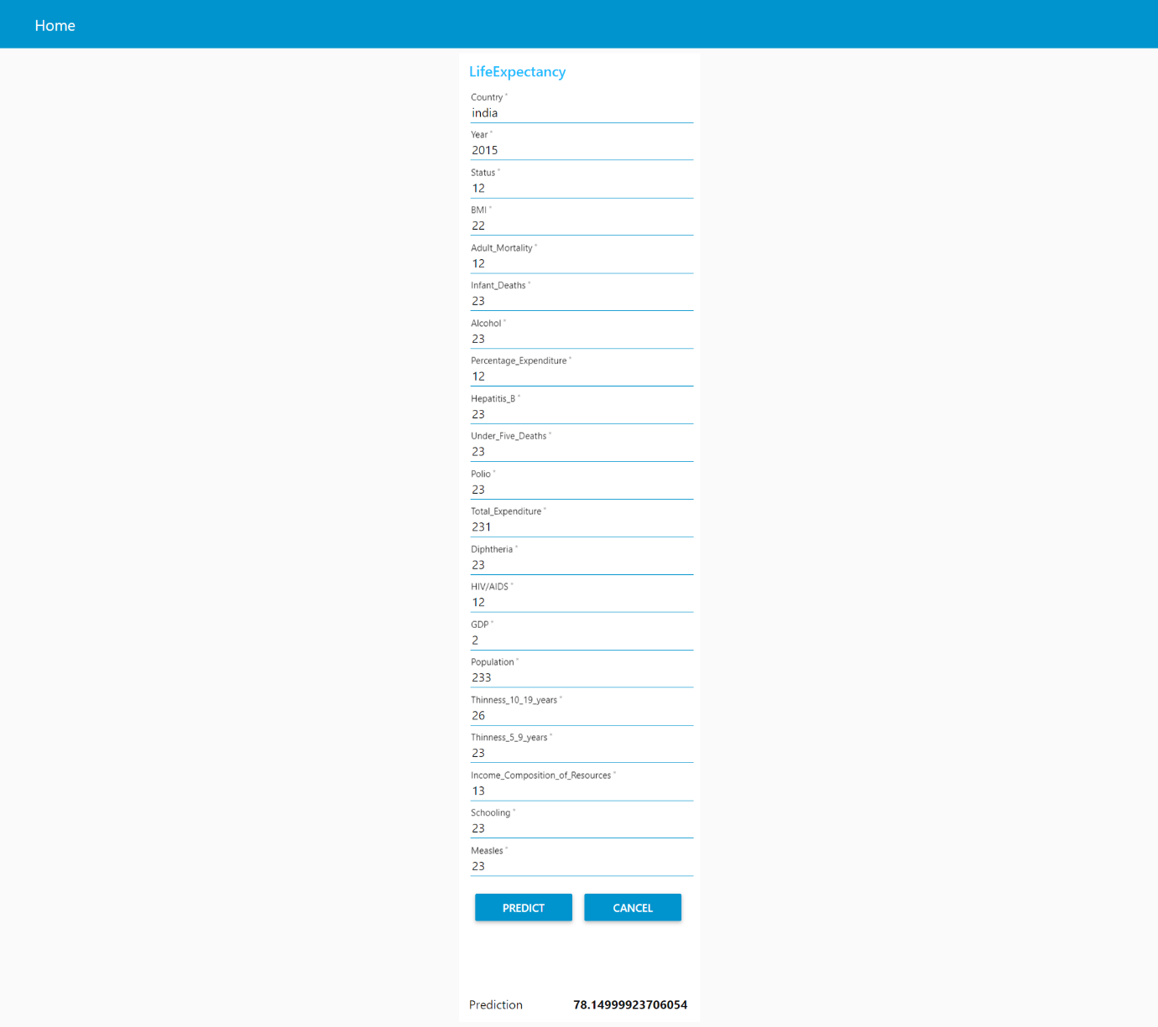

7. ADVANTAGES AND DISADVANTAGES

ADVANTAGES:

1)Helpful for a country for analysis: It will be easier for a country to determine the predicting factor which is contributing to lower value of life expectancy. This will help in suggesting a country which area should be given importance in order to efficiently improve the life expectancy of its population.

Life expectancy can be used nationally to monitor health inequalities of a country.

2) Reduced Costs: This is a simple webpage and can be accessed by any citizen of a country to calculate life expectancy of their country and does not required any kind of payment neither for designing nor for using.

3) User Friendly Interface: This interface requires no background knowledge of how to use it. It’s a simple interface and only ask for required values and predict the output.

DISADVANTAGES:

a)Prediction may not be accurate: As it depends completely on user, so if user provides some wrong values then it will predict wrong value.

b) Average Prediction: The model predicts average or approximate value with 94.07% accuracy but not accurate value.

c)User input is not saved in any database.

8. APPLICATION

a) It can be used to monitor health inequalities of a country.

b) It can be used to develop statistics for country development process.

c) It can be used to analyse the factors for high life expectancy.

d) It will help government prepare life insurance policies for people .

9. CONCLUSION

We have prepared a model that will predict the life expectancy of a person in a country.

The end product which is a user interface which will be useful for the user to predict life expectancy value of their own country or any other country based on some required details such as GDP, BMI, Year, Alcohol Intake, Total expenditure and etc.

11. BIBLIOGRAPHY

* <https://cloud.ibm.com/docs/overview?topic=overview-whatis-platform>
* <https://developer.ibm.com/tutorials/how-to-create-a-node-red-starter-application/>
* <https://nodered.org/>
* <https://github.com/watson-developer-cloud/node-red-labs>

<https://www.kaggle.com/kumarajarshi/life-expectancy-who>

APPENDIX:

source code can be found at the github link:

<https://github.com/SmartPracticeschool/llSPS-INT-2065-Predicting-Life-Expectancy-using-Machine-Learning>